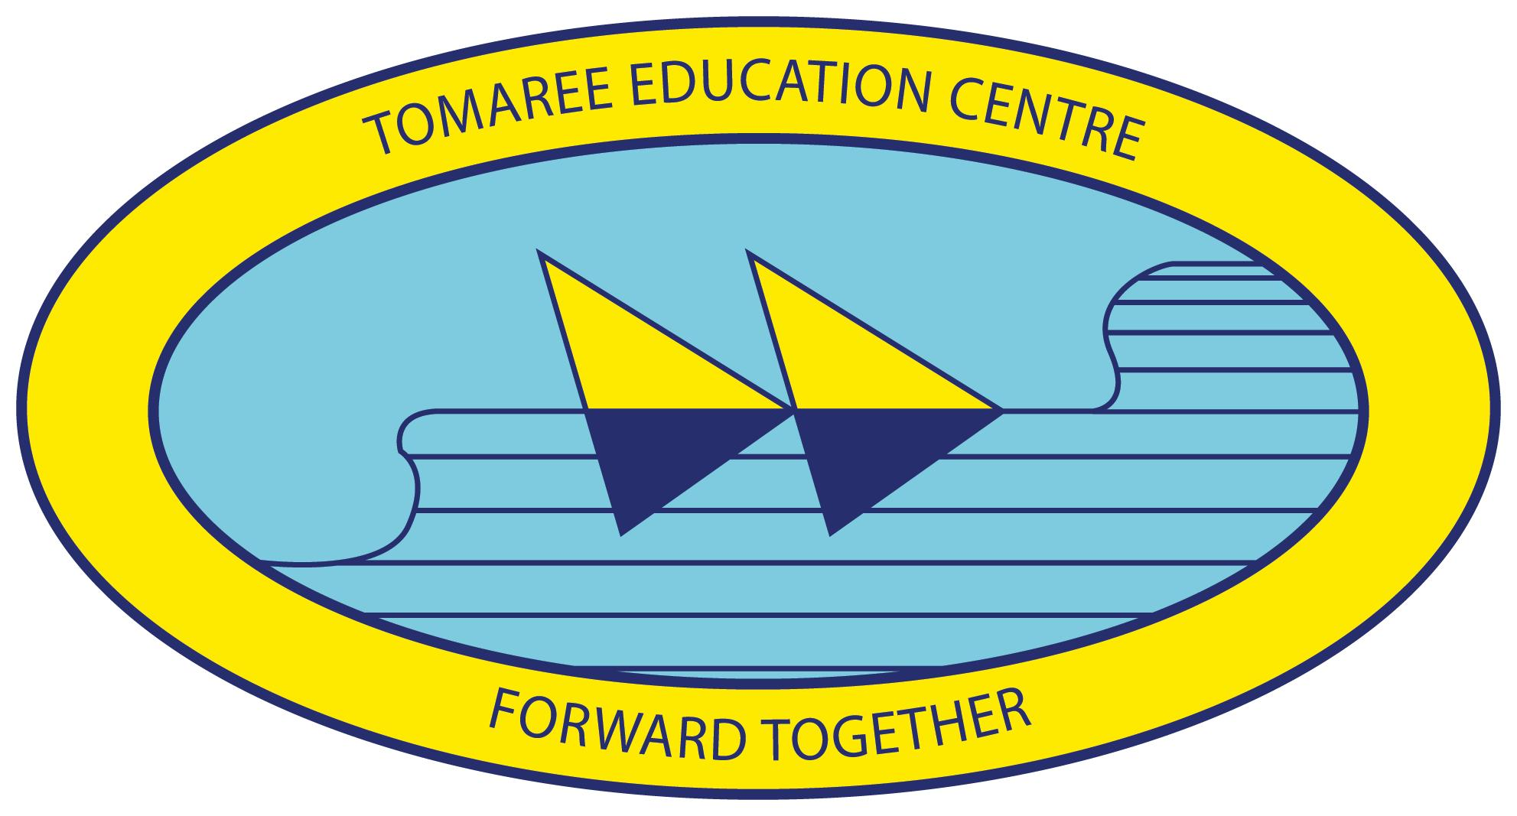
School Improvement plan 2015 – 2017

Part A: School Plan | Tomaree Public School

School Background 2015 - 2017

School Vision Statement
At Tomaree Public School we believe that if we work in meaningful partnerships within and beyond the school community we will inspire the development of lifelong learners who strive to reach their full potential. We believe that developing confident, creative and engaged students is reliant upon maximising every individual’s opportunity to participate. We believe that engaged students who have strong relationships, are motivated and independent learners, have the capacity to become active, informed and responsible citizens.
School Context
Tomaree Public School is located in Port Stephens at Salamander Bay. Tomaree Public School is an integral part of the Tomaree Education Centre, with Tomaree High School and the Hunter Institute of TAFE. The three entities work in a unique partnership to enhance learning opportunities for students across the Tomaree Peninsula, utilising shared resources and facilities to be an effective provider of high quality education in the 21st Century.
Our school has a non - teaching principal, five assistant principals, 19 classroom teachers including 3 special education classes, a full time learning and support teacher, a full time Teacher Librarian and two various support teachers who specialise in music, drama and art. We are heavily supported by a SAM and SAO and a GA who all work tirelessly to support our vision.
The school population of 416 includes 19 Aboriginal students, 47 students of Defence force families and 32 students with language backgrounds other than English. Our population is very transient and we have regular deployment of Defence families so we have a mobility rate which is high. Tomaree Public School caters for a wide range of activities, including performing arts, sporting, cultural, leadership, environmental and academic pursuits to ensure our students have a rich and varied education.
Tomaree Public School has a high percentage of students not reaching expected growth in all areas of NAPLAN. Improving this result will be a strong focus for programs of improvement during the next three years.
Tomaree Public School is supported by an active P&C and has strong community links and developing partnerships. We work together to maintain a school environment that is safe, pleasant, well maintained and rich in learning opportunities.
School Planning Process
In 2014, a comprehensive process was undertaken across the school community to review current practices and collect evidence, including student achievement results, behaviour, participation and effectiveness. A series of activities were held with staff, students and parents to review the strengths, opportunities and areas for future developments across the school. During the process it was recognised that consultation with the local AECG, throughout the school planning process, needs to be strengthened and this has been addressed in the body of the plan. Activities included;
- Staff workshops, including; whole staff, executive and small group activities
- Surveys, including; staff, student, parents
- Discussion groups including; students, staff, parents ( including ATSI) and P&C association
As a result, three strategic directions were identified as a basis for future development. The Tomaree Public School Improvement Plan forms the basis for the school’s improvement and development efforts for the next three years.
School Strategic Directions 2015 - 2017
Strategic Direction 3
PARTNERSHIP
Students and staff develop strong connections within and beyond the school community.

Strategic Direction 2
PARTICIPATION
Students and staff are supported, engaged and participate fully in all learning opportunities.
Strategic Direction 1
PERFORMANCE
Students and Staff reach their potential as learners and strive for continual improvement.

Purpose: To sustain a culture in which;
Students and staff work collaboratively with each other, families and the wider community to support and enhance participation and performance at school.
Students forge connections within their community which will support them in becoming active and informed citizens in the global world.
Purpose: To sustain a culture in which;
Students participate in learning that is goal oriented, relevant, differentiated, holistic and supported, leading to engaged and self-motivated learners.
Staff are part of a professional learning community which focuses on; building capacity through professional learning, goal setting and maximising student outcomes.

Purpose: To sustain a culture in which;
Students achieve to their potential and strive for success, leading to optimum outcomes.
Students and staff gain the skills, knowledge and attributes which will enable success in their work.
Staff deliver quality educational programs using consistent, high standard professional practices.
Staff monitor data regularly and student progress will be tracked to drive continual improvement.

Products and Practices
Product: 85% of all students reach grade appropriate continuum clusters in literacy and numeracy and students in K-2 meet L3 Benchmark targets.

85% of students in Years 3,5 & 7 achieve state average growth over a rolling three year average.

Product: 85% of students reach minimum level of sound in school based reporting in English and Mathematics.

Product: Teaching programs reflect assessment for learning, changing pedagogies and curriculum initiatives as evidenced through the TARS process.

Practice: Teachers regularly analyse and reflect on L3 and continuum data.

Practice: Staff actively engage in continued professional learning and collegial dialogue regarding ongoing assessment and pedagogies which support curriculum delivery.

Practice: Stage teams work collegially to ensure consistent teacher judgement of assessment tasks.
Processes
Literacy Improvement Project
Implement the pedagogies of L3 K-2 and Focus on Reading 3-6

Embed literacy across all key learning areas

Monitoring and Tracking
Regular, ongoing tracking of students on the literacy and numeracy continuum in conjunction with stage based reflection and monitoring of literacy and numeracy continuum progress.

Monitor and analyse NAPLAN data and formulate programs to address deficits.

Reflective Practices
Implement a developing structure to enable lesson observation, feedback and monitoring as a way of evaluating performance of students and as part of the TARS process.

Develop a deeper, shared understanding of quality teaching, including a framework for teacher self-evaluation.

Staff develop professional learning plans. Provide professional learning opportunities for meet identified needs.

People
Students: Students understand that learning is achieved by working towards a goal.

Students: understand the criteria for success in a learning experience.

Students: strive for success and ongoing learning.

Staff: through discussion and targeted PL, develop the capacity to identify evidence from data and develop teaching learning programs to meet identified student needs.

Staff: Competently use the Quality Teaching Framework to design and implement engaging 21 century pedagogies into classroom programs.

Parents: will be supported to develop knowledge and understandings of the school’s learning and support programs to assist their students’ to achieve their potential.
Purpose
To sustain a culture in which;

Students achieve to their potential and strive for success, leading to optimum outcomes.

Students and staff gain the skills, knowledge and attributes which will enable success in their work.

Staff deliver quality educational programs using consistent, high standard professional practices.

Staff monitor data regularly and student progress will be tracked to drive continual improvement.

Improvement Measures

85% of students in Years 3,5 & 7 achieve state average growth over a rolling three year average. (Baseline eg averaged growth over 2012,13&14)

85% of all students reach grade appropriate continuum clusters in literacy and numeracy and students in K-2 meet L3 Benchmark targets.

Strategic Direction 1: Performance –Students and staff reach their potential as learners and strive for continual improvement
Purpose
To sustain a culture in which;

Students participate in learning that is goal oriented, relevant, differentiated, holistic and supported, leading to engaged and self-motivated learners.

Staff are part of a professional learning community which focuses on; building capacity through professional learning, goal setting and maximising student outcomes.

Improvement Measures

*Effective Education Plans that are authentic, fluid, ongoing and regularly reviewed.
* Staff have Professional Learning Plans that reflect the schools strategic directions and their own personal learning goals.
* Reduction in student referrals for behaviour issues as recorded in SENTRAL(Baseline 2014)
People
Students: are encouraged and supported to develop their own goals and strategies to achieve them.

Students: are provided with relevant and engaging learning experiences at their level.

Staff: promote personalised learning that aims to fulfil the diverse capabilities of each student and provide all students with access to high quality educational experiences that are inclusive and free from discrimination.

Staff: are provided with programs of personalised professional development through a range of strategies that focus on feedback, self-evaluation and sharing of professional practice.

Parents: are more aware of the school focus on differentiated learning through a multifaceted communication strategy.
Processes
Supported Learning
Refine current systems of accountability around student support by developing Education Plans and Personalised Learning Plans which plan for improvement, are goal oriented and are monitored and reviewed on a regular and ongoing basis.

Strategic support for students aligned with Independent Education Plans and Personalised Learning Plans

Engagement
Maintaining, developing and introducing programs for emotional and social Wellbeing and development.

Differentiated Programs which support learning styles and needs

Innovative practices to engage all students in alternative learning situations

Professional Learning Networks
Creating Professional learning networks and experiences that meet individual needs of staff as per PDP identified PL needs and monitoring these plans on a regular and ongoing basis.

Build capacity of staff around goal setting for their own PL and for use with students.

Products and Practices
Product: Effective Education Plans that are authentic, fluid, ongoing and regularly reviewed combined with differentiated innovative teaching practices which lead to improved outcomes for students, are embedded in teacher practice.

Product: Welfare and support programs that ensure holistic needs of students are effectively met as indicated by Sentral, LST, Welfare team and Student Counsellor records.

Product: Staff have Professional Development Plans that reflect curriculum development, the schools strategic directions and their own personal learning goals.

Practice: All staff are engaged in critical reflection and use formal and informal feedback to develop deeper insights into the effectiveness of their own teaching practice, making ongoing adjustments to maintain best practice.

Practice: Students reflect on their learning and actively engage in goal setting and self-improvement activities.
Strategic Direction 2: Participation – Students and staff are supported, engaged and participate fully in all learning activities
Purpose
To sustain a culture in which;

Students and staff work collaboratively with each other, families and the wider community to support and enhance participation and performance at school.

Students forge connections within their community which will support them in becoming active and informed citizens in the global world.

Improvement Measures

* Parent / community participation in learning partnerships and decision making processes will show a growth of 50% as evidenced by increased number of parent helpers and involvement in parent workshops.
(Baseline 2014)
* A cohesive and productive staff, highly engaged students and supportive parents as evidenced by high level ratings in the TTFM survey.

People
Students: Students respect and value the developing relationships that connect them with their world.

Staff: Through collaborative learning, staff develop the mindset that forming respectful relationships of trust is important to achieve growth
Staff:

Parents: Strengthen the home-school partnerships and bring mutual benefits to maximise student engagement, confidence and wellbeing.

Parents: support and value the educational programs in the school and welcome the opportunity for involvement.
Processes
Develop a communication plan which includes of a parent rep, to focus on the school brand.

A Parent involvement Program which increases the involvement across all areas of the school.

A Community involvement program which focuses on increasing community involvement across the school.

Collegial planning days which allow for staff to work on collaborative planning.

Critical Friend program which develops a mentor type relationship across the school and a culture of reflection.

Participate in the Tell Them From Me survey to evaluate student, staff and community satisfaction with the school.

Global Citizenship development which encourages students and staff to be more aware of global issues and sustainability.

Products and Practices
Product: Parent / community participation in learning partnerships and decision making processes will show a growth of 50% as evidenced by increased number of parent helpers and involvement in parent workshops.

Product: A cohesive and productive staff, with evidence from staff surveys and observation of teaching programs, of improved satisfaction with school processes and outcomes.

Product: An increase in programs and activities which promote meaningful connections within the local and global community and 21st century pedagogies.

Practice: Parents and the wider community, Including the local AECG have regular involvement in school learning programs and actively participate in school planning processes.

Practice: 100% of staff are aligned to the purpose of our school plan and actively support this with a focus on collective efficacy.

Practices: Students are engaged in relevant learning experiences with authentic purposes, which will encourage global thinking and sustainability.
Strategic Direction 3: Partnership – Students and staff develop strong connections within and beyond the school community

